**Purpose:**

Since this device is meant to be used by a variety of individuals due to its goal of being an open source device, we would like for it to be easy to maintain as well as be simple to upkeep. In order to gauge ease of maintenance we will use a user defined scale. We will have the user take apart the dust remover, replace the part with another 3d printed item, and put it back together again. This set of tasks will be our definition of “maintain”. With the assumption that whoever will be using the device is familiar to 3d printing, the test subjects would fall under this category and would be instructed to perform self evaluations using the following table:

| Rank | Description |
| --- | --- |
| 1 | The device cannot be maintained, even with assistance |
| 2 | The device can be maintained with assistance from a trained professional |
| 3 | The device can be maintained while consulting an Assembly Manual |
| 4 | The device can be maintained independently after several attempts |
| 5 | The device can be maintained independently on first attempt |

**Target Test Criteria: Average Score ≥4**

**Results:**

Responses: 39

Average Score: 3.57

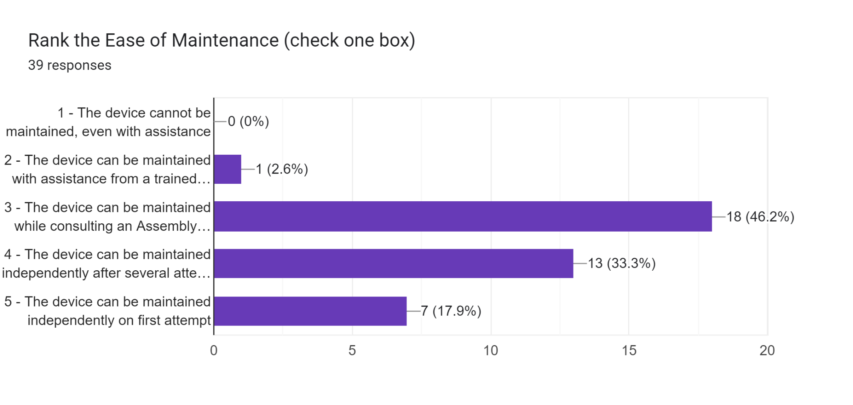

It should be noted that we changed our manual based on observations and recommendations that we and the participants noticed throughout the entirety of the experiments. If the participant didn’t need the manual, they didn’t have any input to the manual. It should be noted that the majority of the population that we tested had at least some experience with a 3D printer, with a few outliers who didn’t have any experience with it.